HOLY TRINITY CHURCH - CROCKHAM HILL

Christ Centered and Community Focused

www.crockhamhillchurch.org

www.facebook.com/CrockhamHillChurch

Sunday 19th January 2020
Epiphany 2

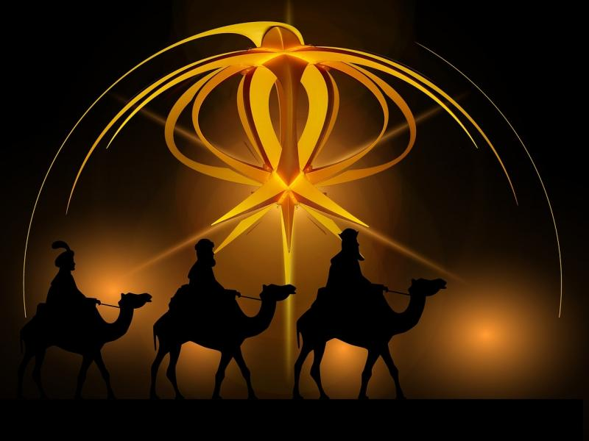

8.00am Holy Communion BCP
10.00am Eucharist Service

6.30pm ECC Churches Together Service
at the Eden Church
HYMNS:

144 - Come, let us join our cheerful songs
526 - When Jesus came to Jordan
224 - Lead us, heavenly Father, lead us
149 - Ye servants of God, your Master proclaim

COLLECT:
Eternal Lord,
our beginning and our end:
bring us with the whole creation
to your glory, hidden through past ages
and made known
in Jesus Christ our Lord.

READINGS: I Corinthians v1-9
1 Paul, called to be an apostle of Christ Jesus by the will of God, and our brother Sosthenes, ² To the church of God that is in Corinth, to those who are sanctified in Christ Jesus, called to be saints, together with all those who in every place call on the name of our Lord Jesus Christ, both their Lord and ours:
³ Grace to you and peace from God our Father and the Lord Jesus Christ.
⁴ I give thanks to my God always for you because of the grace of God that has been given you in Christ Jesus, ⁵ for in every way you have been enriched in him, in speech and knowledge of every kind— ⁶ just as the testimony of Christ has been strengthened among you— ⁷ so that you are not lacking in any spiritual gift as you wait for the revealing of our Lord Jesus Christ. ⁸ He will also strengthen you to the end, so that you may be blameless on the day of our Lord Jesus Christ. ⁹ God is faithful; by him you were called into the fellowship of his Son, Jesus Christ our Lord.

Gospel Reading: John 1 v29-42
²⁹ The next day he saw Jesus coming towards him and declared, ‘Here is the Lamb of God who takes away the sin of the world! ³⁰ This is he of whom I said, “After me comes a man who ranks ahead of me because he was before me.” ³¹ I myself did not know him; but I came baptizing with water for this reason, that he might be revealed to Israel.’ ³² And John testified, ‘I saw the Spirit descending from heaven like a dove, and it remained on him. ³³ I myself did not know him, but the one who sent me to baptize with water said to me, “He on whom you see the Spirit descend and remain is the one who baptizes with the Holy Spirit.” ³⁴ And I myself have seen and have testified that this is the Son of God.’
³⁵ The next day John again was standing with two of his disciples, ³⁶ and as he watched Jesus walk by, he exclaimed, ‘Look, here is the Lamb of God!’ ³⁷ The two disciples heard him say this, and they followed Jesus. ³⁸ When Jesus turned and saw them following, he said to them, ‘What are you looking for?’ They said to him, ‘Rabbi’ (which translated means Teacher), ‘where are you staying?’ ³⁹ He said to them, ‘Come and see.’ They came and saw where he was staying, and they remained with him that day. It was about four o’clock in the afternoon. ⁴⁰ One of the two who heard John speak and followed him was Andrew, Simon Peter’s brother. ⁴¹ He first found his brother Simon and said to him, ‘We have found the Messiah’ (which is translated Anointed). ⁴² He brought Simon to Jesus, who looked at him and said, ‘You are Simon son of John. You are to be called Cephas’ (which is translated Peter).

FOR OUR PRAYERS

- For our Village Community including the School and Pre-school, our pub and all who use the Village Hall

- For all affected by natural disasters, especially the people of Australia

- For wisdom for the leaders of all countries affected by tensions in the Middle East
- For the PCC meeting on Tuesday

- For all our friends in Kongwa and New Cross

This week at Holy Trinity

Tues 21st Jan: 9.15am Morning Prayer in Church
7.30pm PCC Meeting at Woodmote

Weds 22nd Jan: 2.00pm Prayer Group at Woodmote
5.00pm Evening Prayer at the Vicarage
Fri 24th Jan: 8.30am Prayer Breakfast at Crockham Hill Vicarage
Sign-up sheet at the back of church or contact Rev Sue
Sat 25th Jan: 9.30am Deanery Synod St John’s Hildenborough
Open meeting with +Rod Thomas, Bishop of Maidstone

DIARY DATES:

18th – 25th January Week of Prayer for Christian Unity
(see separate sheet for all ECC prayer times)

Saturday 1st Feb at 7.00pm 900th Anniversary of SsPP launch event with Tom Tugendhat MP followed by a concert by the Countess of Wessex String Orchestra. Tickets £20 from Farringtons.

Saturday 8th Feb at 7.30pm in the Village Hall
at last the long postponed ‘Running over the Hill’ Quiz Night.
Anna ran the London marathon and more last year and runs the Edinburgh Marathon this year to raise funds for; Breast Cancer Now, Prostate Cancer and Cystic Fibrosis Trust. Tickets £15 to include supper from richard.diggory@outlook.com or 446466
Bar and fabulous raffle! Teams of 8 needed on the night.

Tuesday 25th Feb ‘Hot Pot Supper’ – tickets £7.50 from Trish.
Sign-up sheet in church for tickets and to help coming soon!

