Holy Trinity Church, Crockham Hill

Remembrance Sunday 2020
November 8 (service held on Zoom)
Reading, by Diana Walsh
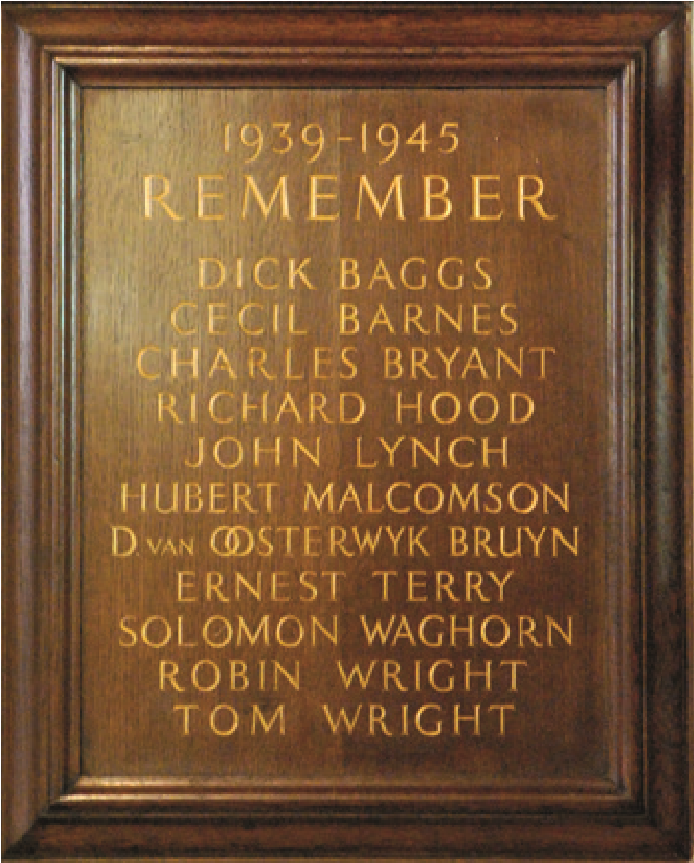
On Remembrance Day two
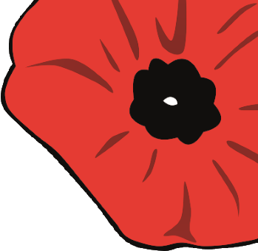
years ago, we paid a special tribute to the men of this village who gave their lives in the First World War, as we marked the centenary of the end of the ‘war to end all wars’. Today, we remember and honour another
generation of this village’s lost men – those who fought in the Second World War. These are some of their stories.

Dick Baggs
Dick had been a chorister here at Holy Trinity, and lived at Harman’s Orchard Cottage in Froghole. His father had served with the Royal Field Artillery in Egypt in the Great War, and was Head Special Constable for this area during World War Two. Dick was a despatch rider in the Field Company Royal Engineers. Tragically, he was killed in a motorbike accident in Maidstone in 1943. He was just 20. He is buried in the churchyard.

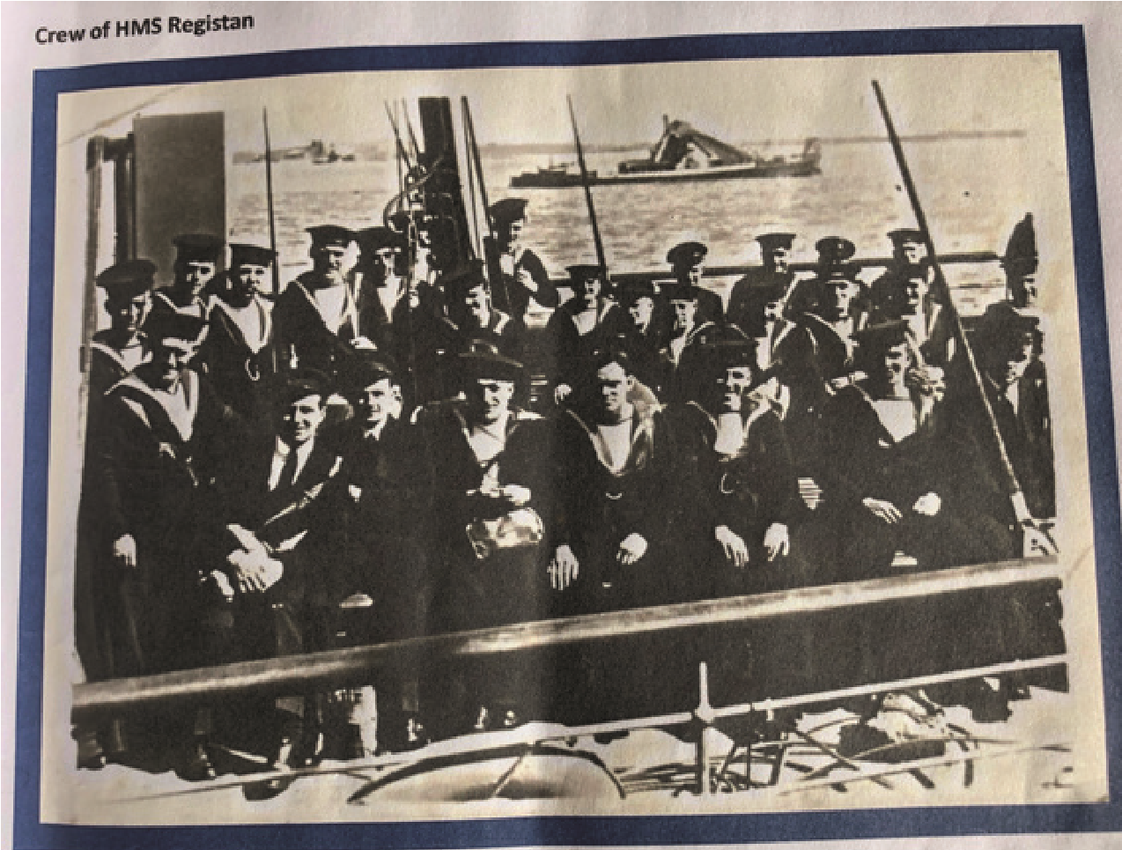
Cecil Barnes
Cecil was the son of Alfred and Emily Barnes, of 4 Rushetts Cottages. He was well known in Crockham Hill and Edenbridge and attended the local schools.
Cecil joined the Navy aged just 17. The Able Seaman served on HMS Registan (pictured) and volunteered for service in the Mediterranean Fleet in both Malta and Gibraltar.
On May 27, 1941, his vessel was bombed by enemy aircraft and caught fire. Sixty-three crew members lost their lives.
Cecil’s name is inscribed on the Chatham Naval Memorial.

John Lynch
Rifleman John trained in Kent for defence of the Channel Coast. He was a member of the London Irish Rifles and he lived at Little Court Cottage.
In November 1943, his battalion travelled to the Middle East. They arrived in the midst of a sand storm – water was scarce and sand smothered everything.
After a night in transit camp, they began a gruelling nine-day trek through the desert to the Suez Canal.
It was here that John died. He is buried at Fayid War
Cemetery on the shore of The Great Bitter Lake in Egypt.
His headstone bears the inscription:
Jesus, Mercy, Mary; Help of your Charity. Pray for his soul. RIP.

Hubert Malcolmson
Hubert (Hugh) lived at Harriages in Dairy Line, and had formerly lived in Ireland and also in Ceylon. He was educated at Bradfield College in Berkshire, where he won distinction as a rifle shot and represented his school at Bisley. After leaving school he worked at Lloyd’s Brokers.
In the spring of 1939, Hugh joined the Battalion of the
London Rifle Brigade and the following year was gazetted to the
Dorsetshire Regiment. He later applied to serve with the Indian Army and became attached to the Punjab Regiment – possibly because of his links with Ceylon.
He died on active service, and is buried in the Karachi War Cemetery. His name is inscribed on the Bradfield College War Memorial.

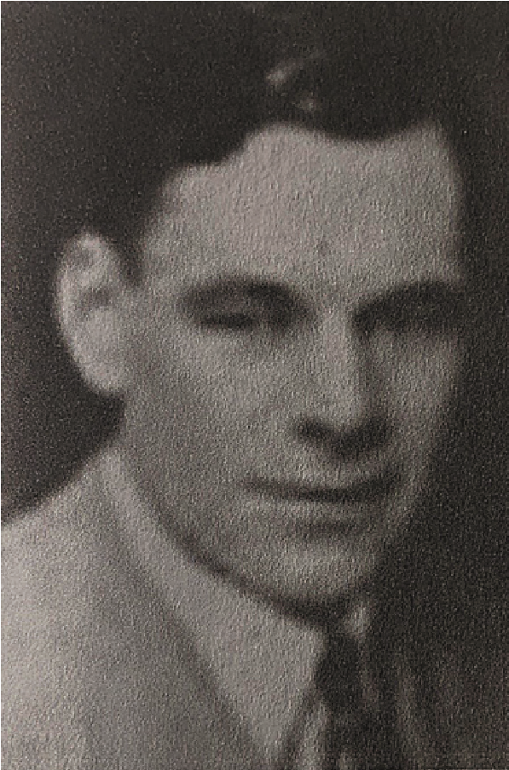
David Van Oosterwyk-Bruyn
David and his family lived in Pootings. He went to Emmanuel College, Cambridge, and graduated with a BA in 1926.
He joined the Royal Naval Volunteer Supplementary Reserve in London in 1937.
In 1940, David (pictured) became a First Lieutenant and joined the crew of HMS Scotstoun. On June 13, while sailing 80
miles west of Barra Island in the Outer Hebrides, the merchant cruiser was hit by two torpedos – causing it to sink. David, together with another officer and five ratings, lost their lives.
His name is listed on the National Memorial in Portsmouth and also on the war memorial in Great Totham in Essex – the home of his recently-widowed wife.

Ernest Solomon Waghorn
Ernest had been in the parish choir in Edenbridge and was a popular member of the Hever Rifle Club. His father worked as a farm labourer at Reynolds Farm near Four Elms, before moving to Acremead Flat in Crockham Hill.
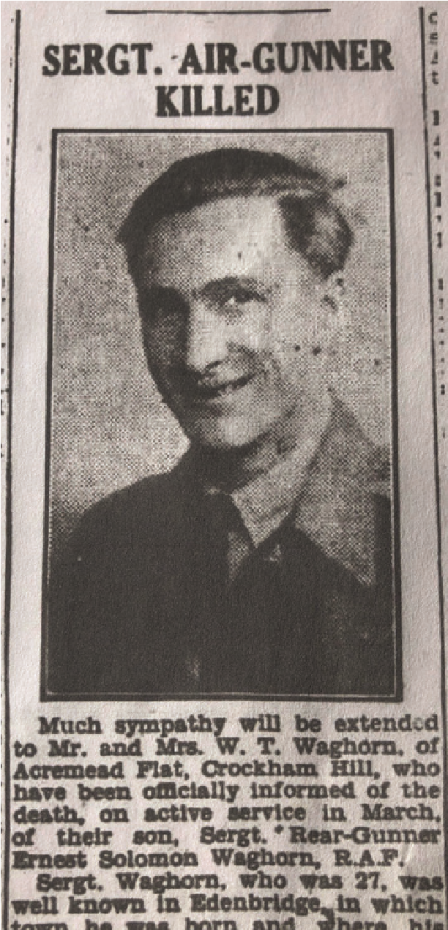
Ernest served as a Sergeant Air Gunner with RAF Squadron 103. On March 9, 1943, his squadron set off on a night-time raid from RAF Elsham Wolds in Lincolnshire on an operation called ‘Munchen’. His aircraft was shot down near Lavannes in northern France. He is buried in Lavannes churchyard, near Reims, along with the rest of his crew.
His parents received a communication from the Red Cross that their son had been buried in France. He was 27.
A memorial service was held for him here in Holy Trinity.

The Wright brothers
Thomas Wright and John Wright had both lived at Guildables Park, here in Crockham Hill.
John was the younger of the two and sadly we know little about him. He was a member of the Royal Corps of Signals, and he was killed while in Antwerp. He is buried in Bruges Cemetery in Belgium.
Thomas fought in both world wars. In the First, he had served in the Third West Kent Regiment; by the Second World War, he was a Major in the Royal Engineers. He fought with the Allied Eighth Army in North Africa. Almost 3,000 of his Commonwealth comrades are commemorated at the Medjez-el-Bab Memorial in Tunisia – but Thomas is not among them. He survived the war, but died in 1949. He is buried here in Crockham Hill.
The Wright brothers’ parents moved to Ashby-de-la-Zouch – and the names of their sons are inscribed on the war memorial in the Leicestershire town.

Battle of Britain
This year marks the 80th anniversary of one of the most renowned conflicts of the war, the Battle of Britain, and it is right that today we remember ‘The Few’ in particular.
In 1939, when war was declared, many young men were eager to join the RAF and to fly the new Spitfires. They were attracted to the airborne service by the comradeship and shared love of flying.
One young pilot, John Magee, aged just 19, wrote a poem about the wonder of flying. He called it High Flight.
High Flight by John Gillespie Magee
Oh! I have slipped the surly bonds of Earth
And danced the skies on laughter-silvered wings;
Sunward I’ve climbed, and joined the tumbling mirth
Of sun-split clouds – and done a hundred things
You have not dreamed of – wheeled and soared and swung
High in the sunlit silence. Hov’ring there, I’ve chased the shouting wind along, and flung My eager craft through footless halls of air...
Up, up the long, delirious burning blue
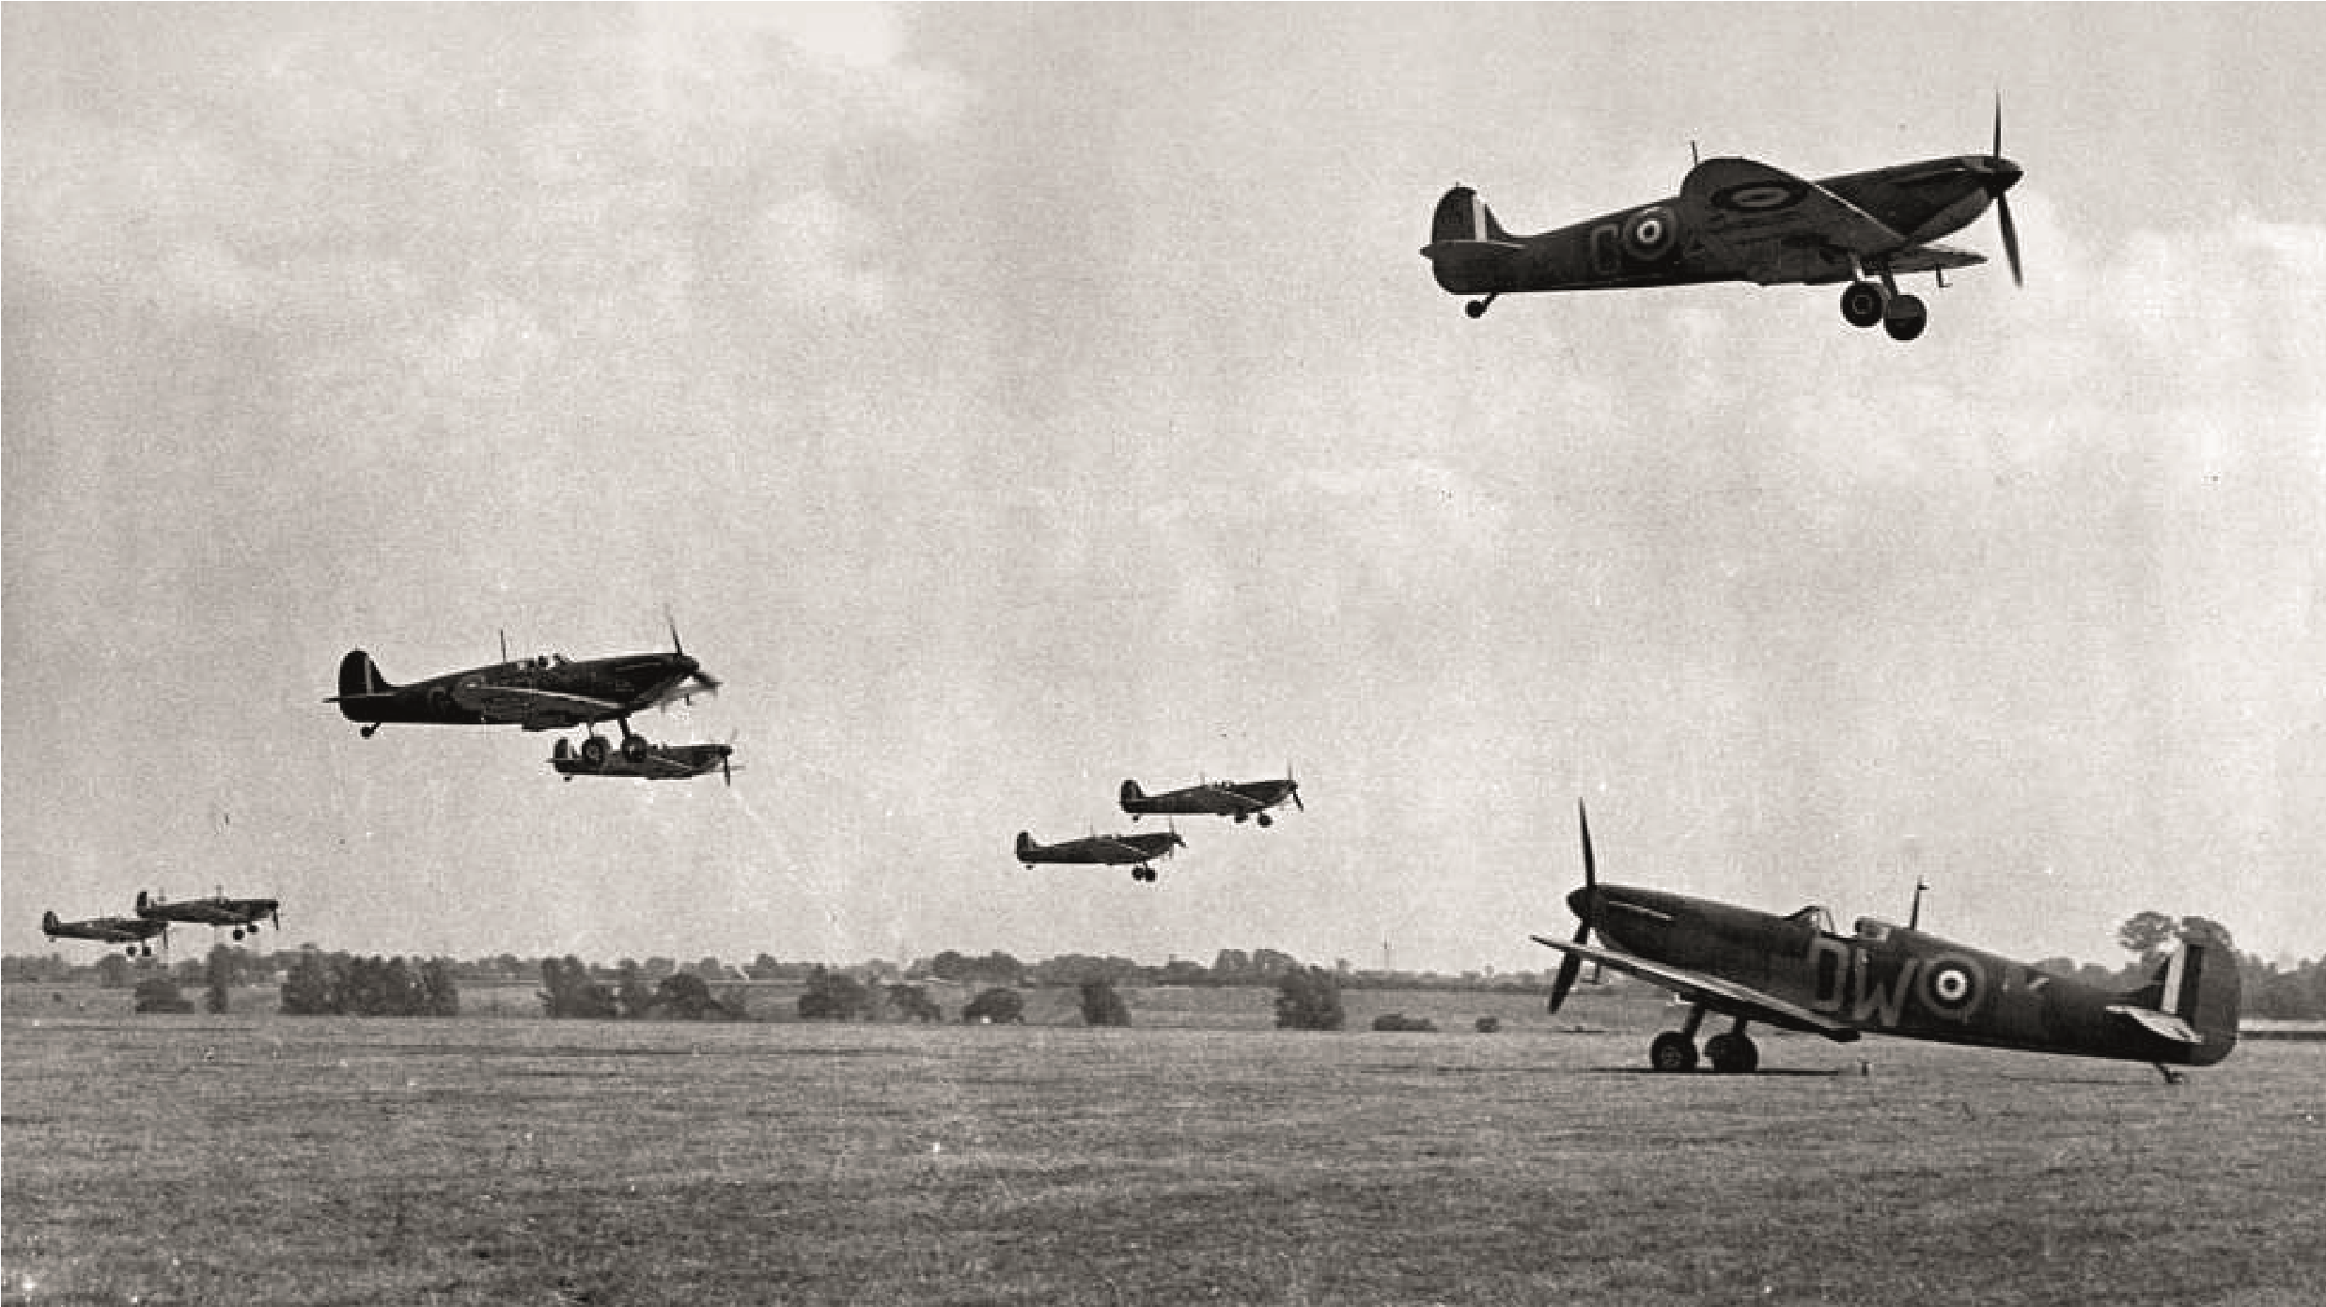
I’ve topped the wind-swept heights with easy grace
Spitfires at RAF Hornchurch, Essex, September 1940
Where never lark, or ever eagle flew – And, while with silent, lifting mind I’ve trod
The high untrespassed sanctity of space,
Put out my hand – and touched the face of God.
But John, and his fellow exuberant pilots, had no idea what awaited them.
It is now 1940. On July 10, the Luftwaffe made its first raid. The aim: to achieve air superiority over the RAF by targeting shipping convoys, ports and the aerodromes of the southeast – among them Biggin Hill and many others in the Home Counties including Kenley, Hornchurch, Luton, Hawkinge and Croydon.
Biggin Hill was bombed on 12 separate occasions. In one day-time raid in August, 39 people on the ground were killed, and 21 more on other raids. Today, they are remembered on a beautiful memorial in Biggin Hill Chapel. Its garden of remembrance also records the names of many of the pilots who survived the war but are no longer with us.
It was a frantic time. Spitfire training was cut from six months to two weeks. Young pilots were scrambled from aerodrome to aerodrome. From Biggin Hill, many air crew took part – and 54 were never to return. But they weren’t just British pilots. The
Allied forces were joined by air crew from Canada, Australia, New Zealand and South Africa, as well as from Occupied countries including Poland, Czechoslovakia and Belgium. They too are honoured at Biggin Hill Chapel.
In daylight, the Luftwaffe bombers would fly in very low. One of the senior members of our congregation, Felicity, remembers it well. She was a teenager then, living in the Gladstone family home at Lewin’s. Felicity says they had a towering Wellingtonia tree in the garden and she recalls on one occasion looking up and seeing an enemy aircraft flying low past the right-hand side of the tree just as on oncoming Spitfire flew past to the left.
Visual reminders of the Luftwaffe raids are still all around us. Aircraft that had been unable to drop their bombs on their intended targets in London did so instead on their return journeys – and if you walk through the woods of Crockham Hill Common and around Limpsfield you can still clearly see the gaping craters they created.
The impact of the Battle of Britain on the civilian population was devastating. More than 43,000 people were killed, mainly in London and the southeast.

Richard Hood
In Crockham Hill, we pay tribute to pilot Richard Hood.
Born in 1908, he was educated at Hazelwood and Tonbridge School. In 1927, Richard was accepted as a cadet at the RAF College at Cranwell. He played hockey for the college, alongside fellow cadet Douglas Bader.
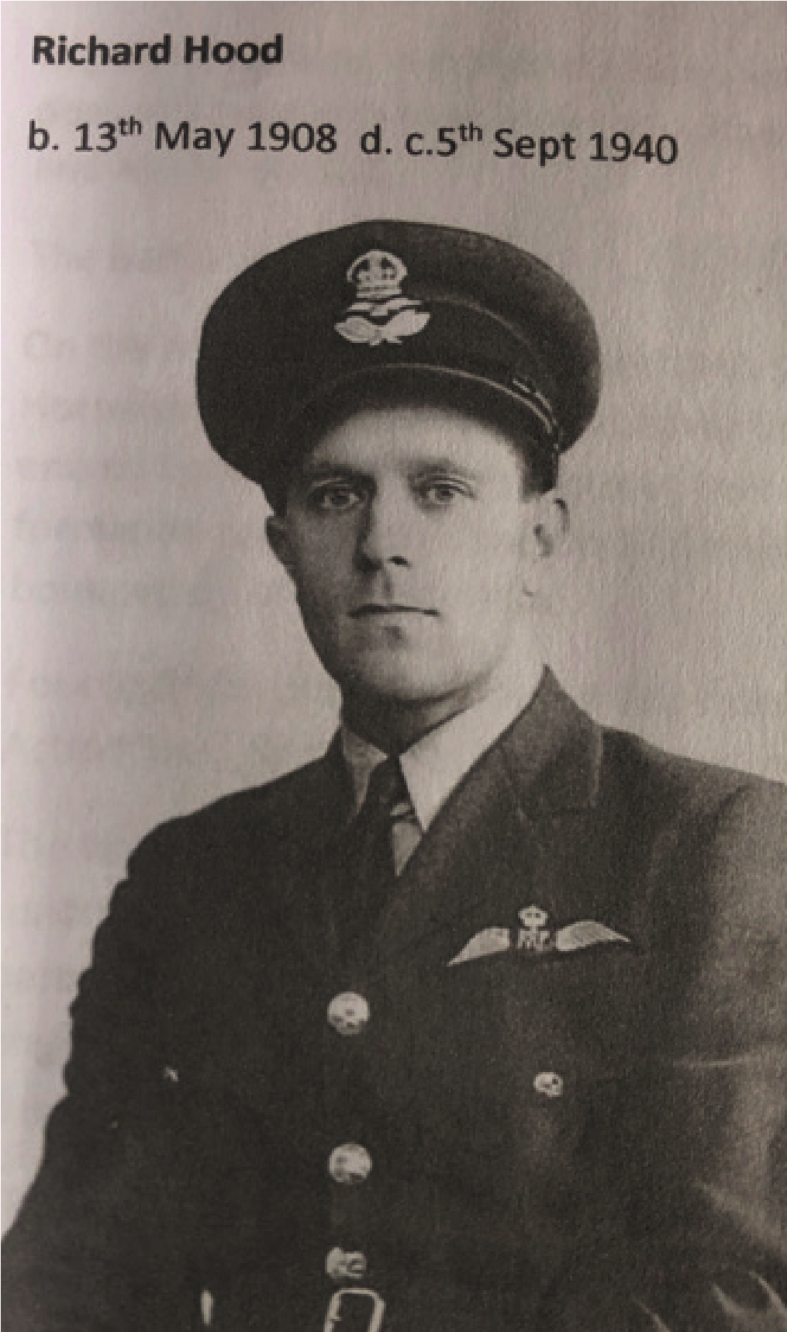
In 1929, he was posted to No 23 Squadron at Kenley, and later served in China and in the Philippines.
In 1935, he returned to
Biggin Hill as Chief Flying
Instructor. By the time of the Battle of the Britain, he had taken command of an RAF Squadron flying Spitfires. Now 32 years of age, he was one of the oldest pilots to take part in the battle.
On September 5, 1940, Squadron Leader Richard led 12 Spitfires, with orders to patrol over Maidstone.
They met a large enemy bomber formation over the Thames
Estuary. Richard led his squadron in line and attacked the Luftwaffe bombers head on. But the enemy aircraft met fire with fire – and four of the 12 Spitfires failed to return. Richard’s was one of them.
He was reported as having tried to bail out, but his parachute had become entangled and his aircraft crashed near Nevendon in Essex.
It was thought – though not confirmed – that he was buried
in a German grave by mistake. He was officially recorded as missing in action.
Richard Hood’s name is engraved on the Runnymede memorial and also the Tonbridge School war memorial.
At the time of his death, his home was at Jacob’s Ladder, here in Crockham Hill.
Weep for them;
Weep for the youth that laugh so bright, Extraneously fallen in the fight.
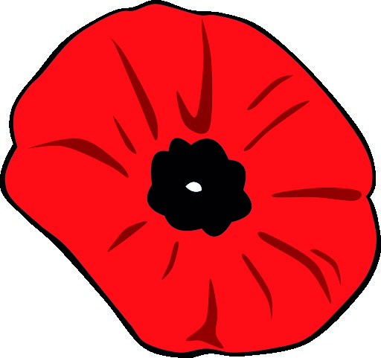
Written by Diana Walsh, based on original research by Barbara Mitchell

